**Property Management Application Using Salesforce - (Developer) – ( Long-Term)**

ID:  LTVIP2024TMID11592

**Team leader:** N.INDHUMATHI

**Team member:**  SREENIVASULUGARI INDHU

**Permission Set**

A permission set is a collection of settings and permissions that give users access to various tools and functions. Permission sets extend users' functional access without changing their profiles. Users can have only one profile but, depending on the Salesforce edition, they can have multiple permission sets.

**Create Permission Set**

1. Go to setup ? type “permission sets” in quick search ? select permission sets ? New  
   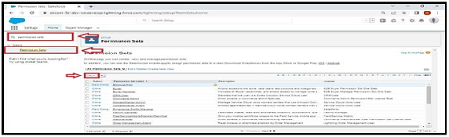
2. Enter the label name (Sales Rep Advance) ? save  
   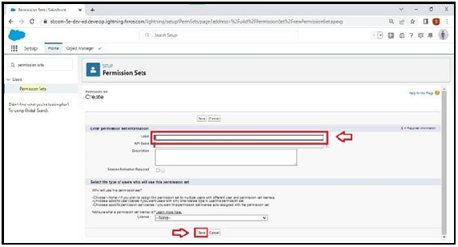
3. Select Object settings  
   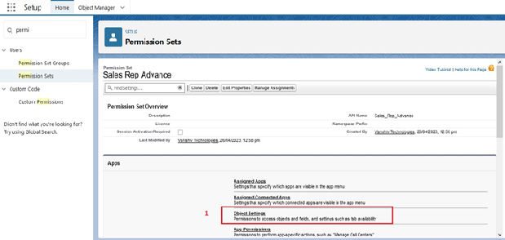
4. Search object property and select property object. and click Edit button  
   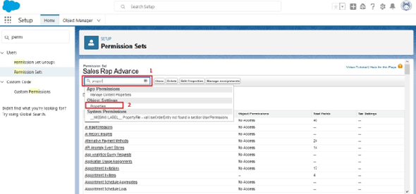
5. In Object Permission we give View all permission. And click save button  
   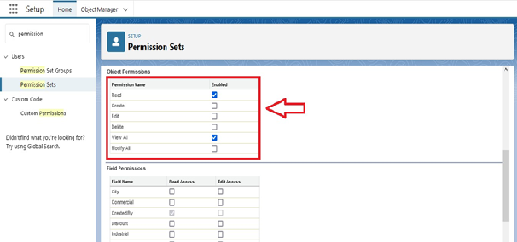
6. Repeat 4th and 5th steps for Enquiry and Loan objects.
7. After saving the permission click on the Manage assignment  
   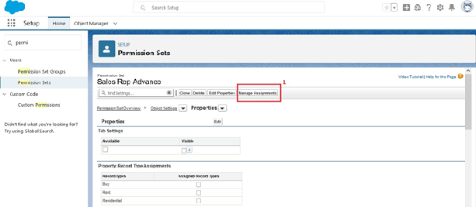
8. Now click on the Add Assignment  
   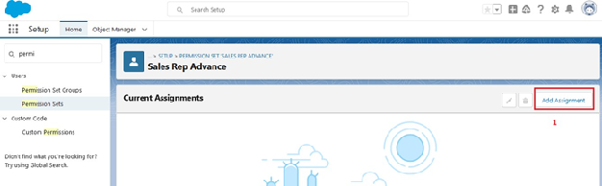
9. Now select the user (sunny) and click on next & assign.  
   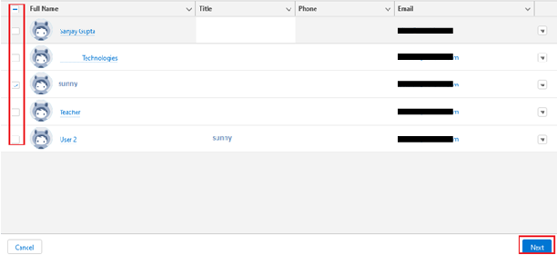

**Set Up For OWD**

Organization-Wide Defaults, or OWDs, are the pattern security rules that you can follow for your Salesforce instance. Organization Wide Defaults are utilized to confine who can access what information in your CRM. You can award access through different methods that we will discuss later (sharing principles, Role Hierarchy, Sales Teams, and Account groups, manual sharing, and so forth).  
  
Primarily, there are four levels of access that can be set in Salesforce OWD and they are-

1. Public Read/Write/Transfer (only available of Leads and Cases)
2. Public Read/Write
3. Public Read/Only
4. Private

**Create OWD Setting**

1.Setup, use the Quick Find box to find Sharing Settings.  
2.Click Edit in the Organization-Wide Defaults area.  
3.For each object, select the default access you want to give everyone.  
4.To disable automatic access using your hierarchies, deselect Grant Access Using Hierarchies for Enquiry, Property custom object

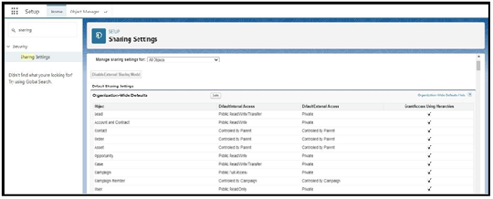  
5.Click Edit and from the Drop Down select private for internal and external  
6.This Setting is for all the User Which have been Created  
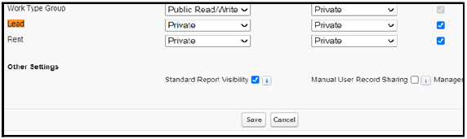

### User Adoption

**Create A Record(Enquiry)**

1. Click on App Launcher on left side of screen.
2. Search Property Management & click on it.
3. Click on Inquiries Tab.
4. Click new and fill details & Save  
   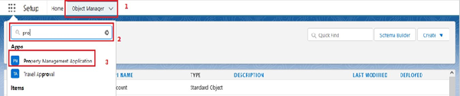  
   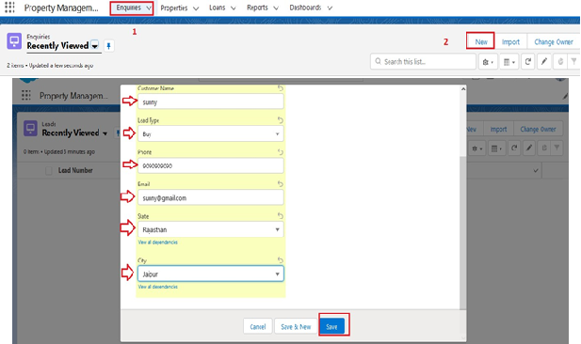

**View A Record(Enquiry)**

1. Click on App Launcher on left side of screen.
2. Search Property Management & click on it.
3. Click on Inquiries Tab.
4. Click on any record name. you can see the details of the Event

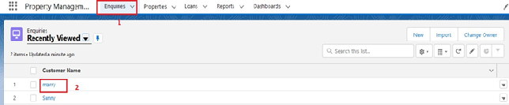

**Delete A Record(Enquiry)**

1. Click on App Launcher on left side of screen.
2. Search Property Management & click on it.
3. Click on Inquiries Tab.
4. Click on Arrow at right hand side on that Particular record.
5. Click delete and delete again.

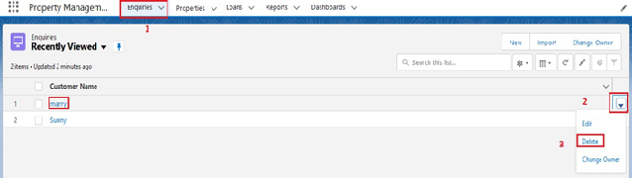

**Report**

Reports give you access to your Salesforce data. You can examine your Salesforce data in almost infinite combinations, display it in easy-to-understand formats, and share the resulting insights with others. Before building, reading, and sharing reports, review these reporting basics.  
   
Types of Reports in Salesforce

* Tabular
* Summary
* Matrix
* Joined Reports

**Create Report**

1. Go to the app ? click on the reports tab  
   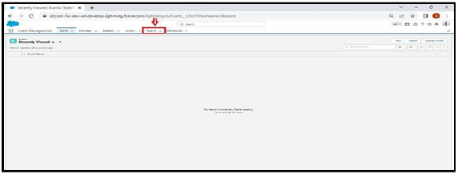
2. Click New Report  
   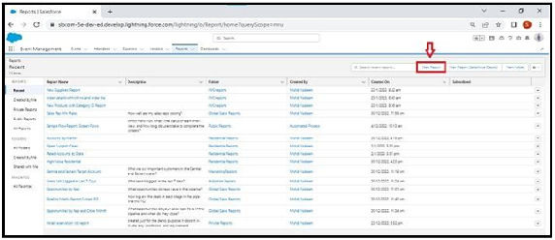
3. Select report type from category or from report type panel or from search panel (properties with customer name) ? click on start report.  
   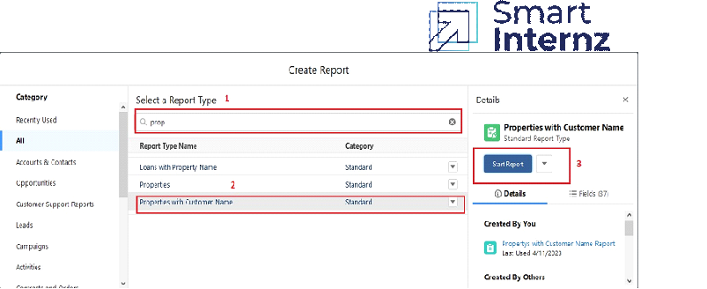
4. Customize your report, add fields like property name, customer name, city, property type etc. Click on save& run (Properties with Customer Name Report)
5. 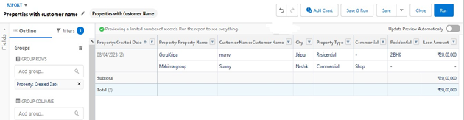
6. Create Report for following Condition
7. Create the Report of the Total Number of Loan Passed for getting the Amount For the Property
8. The Condition should be Like Loan Amount >= to 5000$